**Step scaling:**

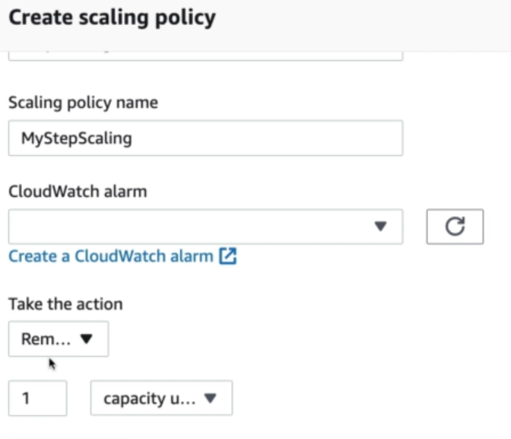

* This one is used with CloudWatch metrics.

**Simple scaling:**

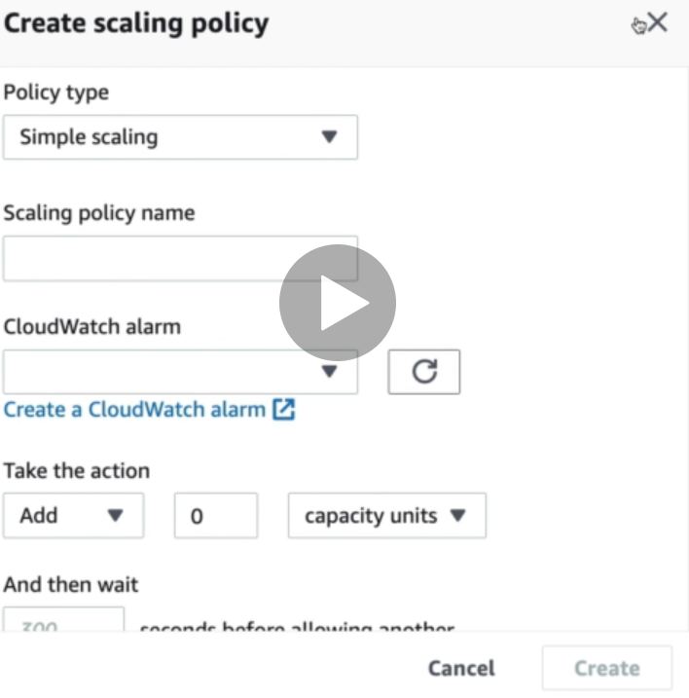

* This is also almost same with limited options.

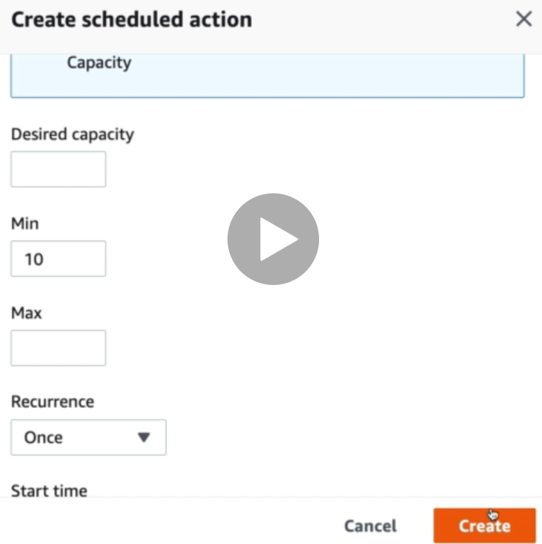

* We can select scheduled actions under ASG. We can give the desired capacity, select date and time etc. and it will be scaled on that time.